Fixed Station Terminal – DT-5365 Series
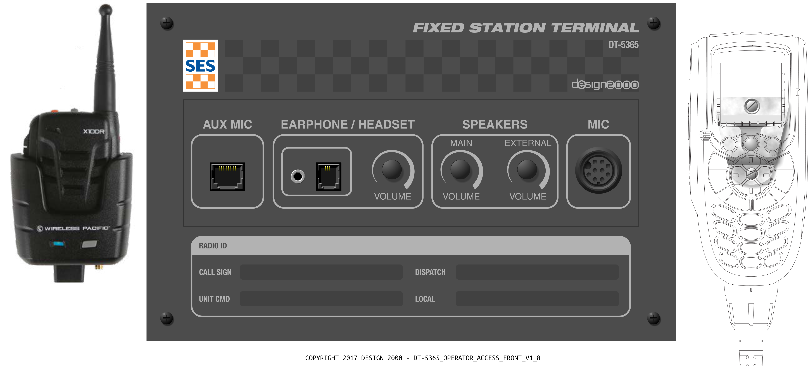

ASTRO® 25

APCO Project 25 Phase 2 Compliant

__________________________________________________________________________________

Installation & Service Handbook

Item 1 of List of Deliverables
Document Number T/18237
Draft 1.0 – January 2018

__________________________________________________________________________________

Design Two Thousand Pty Ltd
9-11 Rose Street
Upper Ferntree Gully
Melbourne, Victoria, 3156
Australia

Australian Business Number: 45 005 014 639

Telephone: +613 9758 5933
Facsimile: +613 9758 5560
Email: gen@design2000.com.au
Web Site: www.design2000.com.au

© 2018 - Design 2000 Pty Ltd


Est. 1968

DOCUMENT CONTROL

Document Number |  | T/18237
Document Name |  | DT-5365 Series Installation & Service Handbook
Security |  | Commercial In Confidence
Circulation |  | Victoria State Emergency Service, Motorola Solutions Australia Pty Ltd., Design 2000 Pty Ltd., Telstra Corporation Ltd., Licensed Installers
Prepared By |  | Peter Zeug, Jed Street
Reviewed By |  | Josh Gamble, Paul Engler
Approved By
Version Control | Edition |  | Date | Notes
 | Draft 1 |  | 23/01/2018 | Initial version

FIXED STATION TERMINAL
DT-5365

SECTION | CONTENTS | PAGE
1
1.1
1.1.1
1.1.2
2
2.1
2.2
2.3
3
3.1
3.2
3.3
4
5
5.1
5.2
5.3
5.4
5.5
5.6
5.7
5.8
5.8.1
5.8.2
5.9
5.10
5.11
5.12
6
6.1
6.2
6.3
6.3.1
6.3.2
6.3.3
7
7.1
7.1.1
7.1.2
7.1.3
7.1.4
7.1.5
7.1.6
7.1.7
7.2
7.3
7.4
7.5
7.6
7.7
7.8
8
8.1
8.2
8.3
8.4
8.5
8.6
8.7
8.8
8.9
8.10
8.11
8.12
8.13
9
10
10.1
10.2
11
11.1
Appendix A | Feature Sets | 41
Appendix B | Circuit – Hierarchy schematic | 42
Appendix C | Circuit – Audio, E&M schematic | 43
Appendix D | Circuit – Amplifier schematic | 44
Appendix E | Circuit – Sub-board schematic | 45
Appendix F | Circuit – Power Supply schematic | 46

Est. 1968

______________________________________________________________________________________________

Assumptions

This document assumes that qualified installers and maintenance technicians perform the installation and maintenance procedures and are therefore aware of basic wiring and installation ‘Industry Best Practices’.

The Occupational Health & Safety of all personnel working on or near this equipment is the responsibility of the installer or technician performing the tests, or operations.

Warning

This equipment may contain lethal voltages, and must be isolated from the mains electricity supply before any cover is removed.

Warranty

The Fixed Station Terminal Units have a Two Year Warranty against defects in Materials and Workmanship.

If problems are experienced with the installation or operation of the Fixed Station Terminal Unit please call the Help Desk Number listed below before returning units to the factory for repair.

In many cases, problems can be diagnosed and rectified over the phone, avoiding unnecessary transportation and service costs.

HELP DESK 03 9758 5933 (All Hours)

______________________________________________________________________________________________

FUNCTIONAL DESCRIPTION
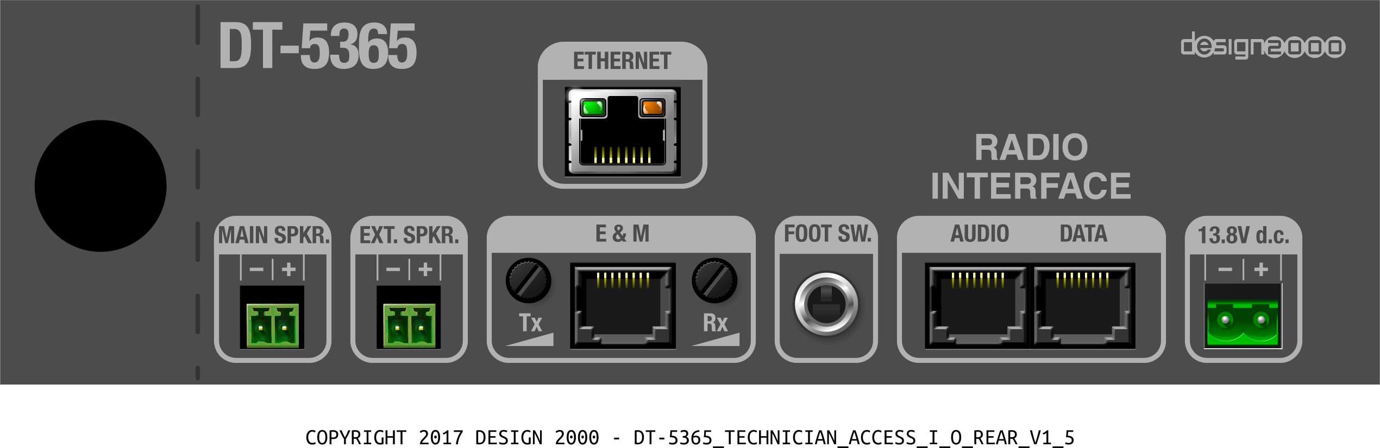

Figure 1: DT-5365 Front Figure 2: DT-5365 Rear

GENERAL FEATURES
The Victorian SES Fixed Station Terminal is a desktop APX2500, APX4500, APX6500, APX7500, or APX 8500 Mobile Radio Console for use in an office environment or temporary location.

The Fixed Station Terminal is powered by the Standard VIC SES Radio Power Supply arrangement.
The DT-5365 has the capability to:

- Operate from a 12V d.c. nominal Supply and/or Rechargeable battery
- Power an external 5W nom., 4-8 Ohm passive PA speaker (volume control knob on front)
- Provide an E&M interface for an external mic/spkr or CCGW (Tx/Rx) arrangement
- Interface an external desk microphone or
- Interface an external wireless microphone
- Interface an external lightweight headset/microphone or
- Interface an external earphone (Smartphone style earbuds/mic)
- Interface an external PTT foot pedal
- Drive a main speaker (volume control knob on front)

These interfaces meet telecommunications network connection safety and level requirements (AS/NZS 60950 and ACMA TS 006 Clause 5.2.2 (a)). The Fixed Station Terminal Interface audio break-outs are buffered to allow operation of all facilities simultaneously. Preset volume controls for the E&M Interface are accessible via recessed, screwdriver adjustable, controls located on the rear panel. Receive volume for the earphone/headset, main speaker and extension speaker are controlled by the knobs on the front panel of the Operator Control Panel Box.

    - Operating Conditions

The Fixed Station Terminal operates under the following physical conditions:

Power source: 13.8V d.c. (12V d.c. nominal).
Nominal output current rating: Continuous 5.0 Amps @ 13.8V d.c.
20 Minutes @ 20% duty cycle 7.5 Amps @ 13.8V d.c.
Temperature: Ambient temperature range -10°C to 70°C with a relative humidity of 0 to 90% non-condensing while mounted in the cabinet.

Microphone Cradles

The DT-5365 has a microphone cradle supplied which is mounted on the melamine laminated MDF cabinet on the right hand side of the SES Faceplate.

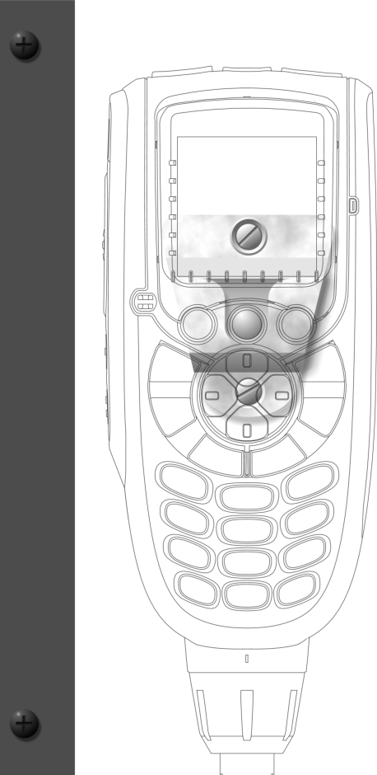
MIC CRADLE

HOUSING CONCEPT
There are two variants (at this time) of the VIC SES faceplate. The physical construction consists of a melamine laminated timber cabinet that holds the Faceplate, Operator Control Panel Box (FP-5365 version), APX Mobile radio, mic cradle (and antenna connector which is on the back of the APX radio). The FP-5365P does not contain the Operator Control Panel Box.

Fixed Station Terminal melamine laminated MDF cabinet
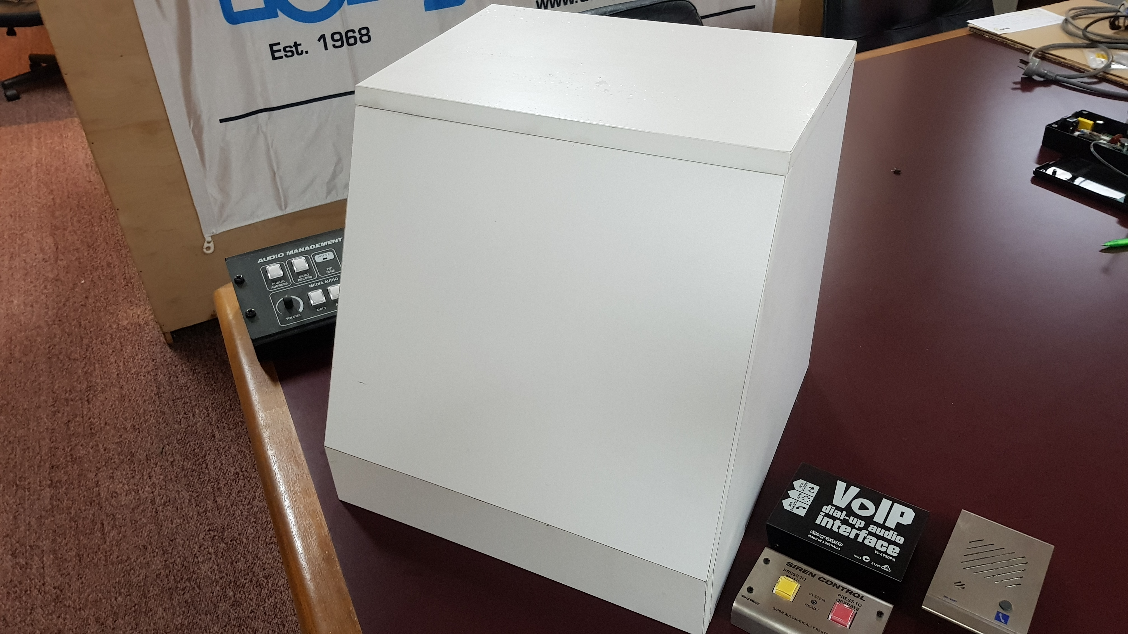

Fixed Station Terminal DT-5365
This version includes the Operator Control Panel Box DT-5365 mounted in the Faceplate FP-5365

250mm

230mm

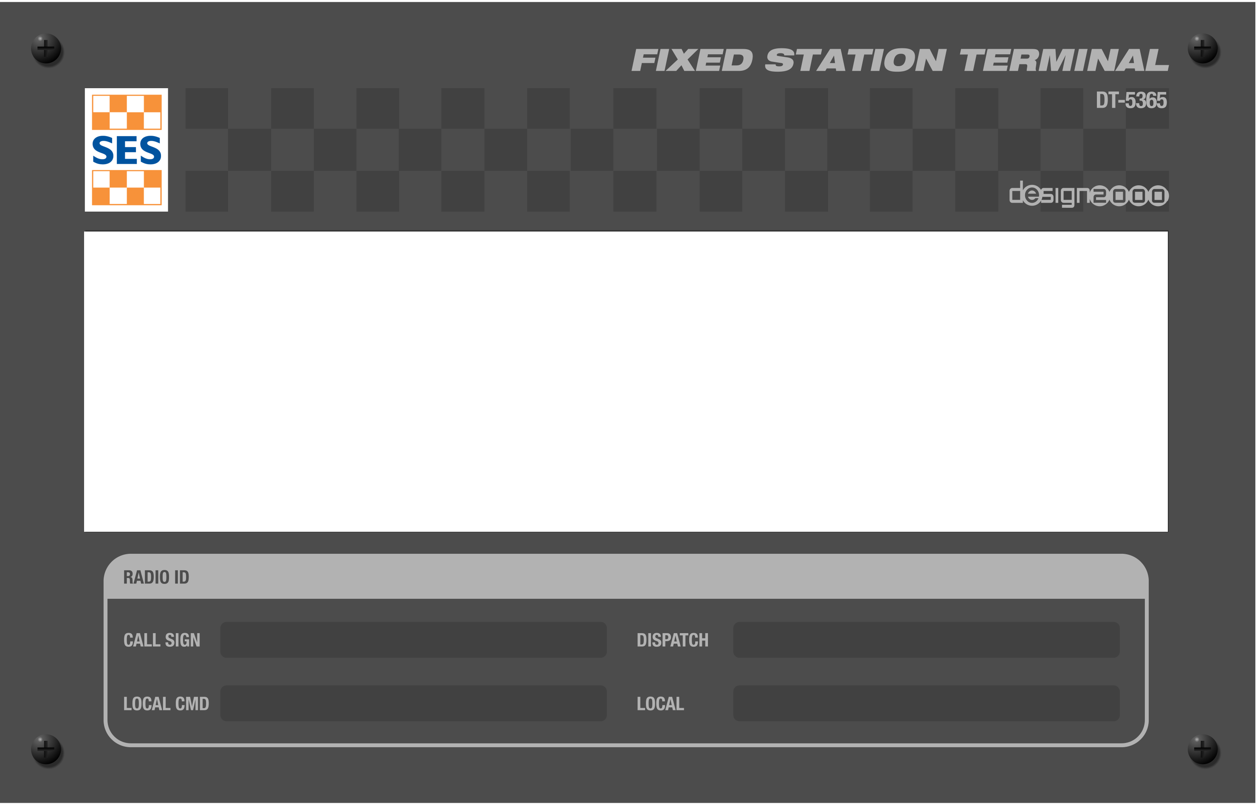

160
mm
140
mm

Faceplate FP-5365 dimensions are 250mm wide
The Operator Control Panel box is fixed to the Faceplate using the brackets and screws supplied.
by 160mm high. 4 mm diameter screw hole centres
are inset by 10mm from each edge
This fits the standard VIC SES cabinet cut-out.

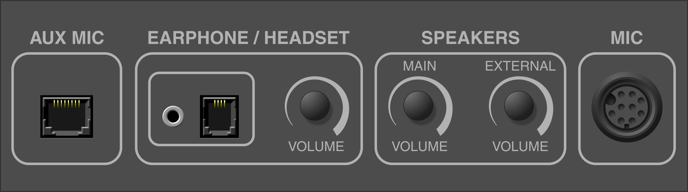

DT-5365 Front
50mm x 200mm x 150mm (H x W x D)

DT-5365 Rear

50mm x 200mm x 150mm (H x W x D)

The height of the Operator Control Panel box DT-5365 is 50mm, the width is 200mm and the depth is 150mm.

Fixed Station Terminal DT-5365P
This version has a plain Faceplate FP-5365P with no Operator Control Panel Box. The controller mic socket and cradle is included.

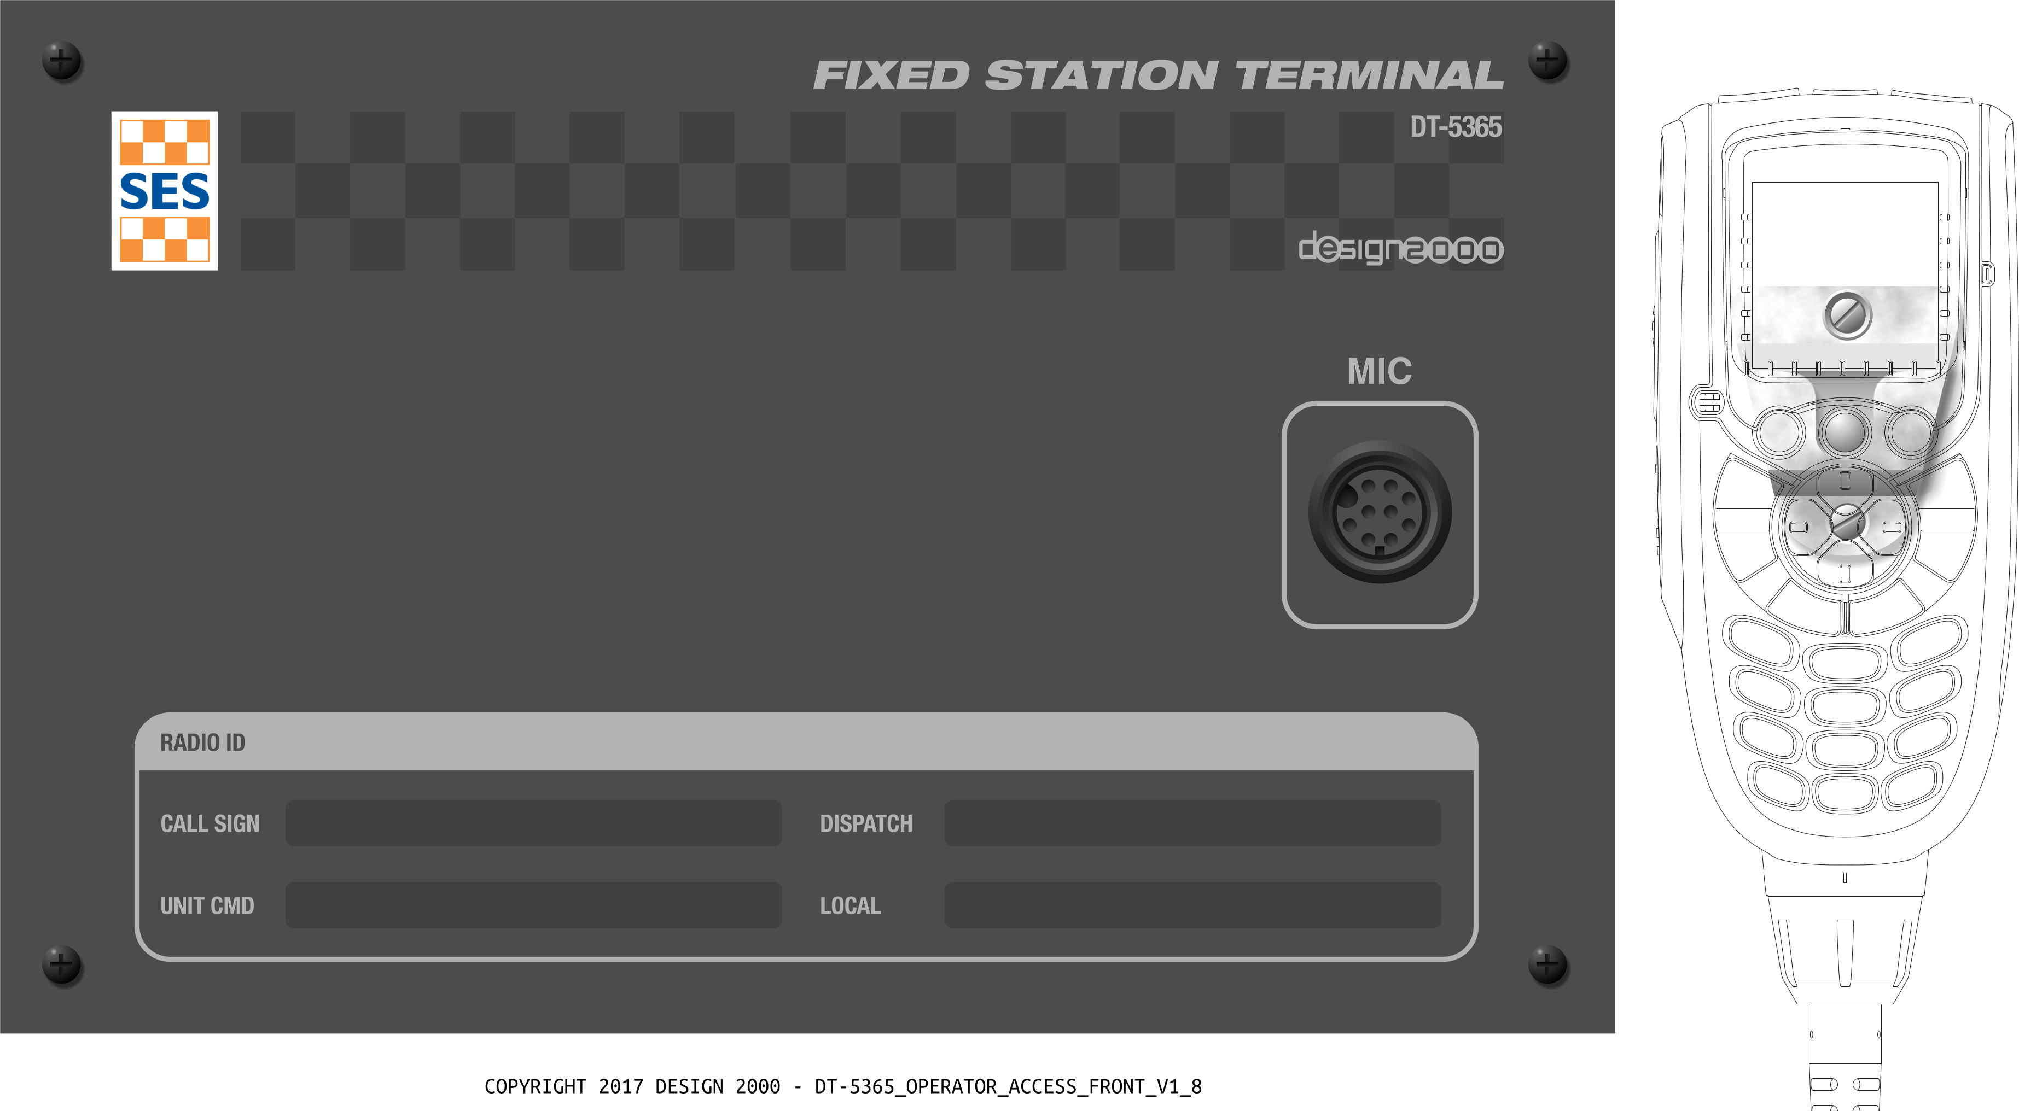

Faceplate FP-5365 dimensions are 250mm wide
by 160mm high. 4 mm diameter screw hole centres
are inset by 10mm from each edge
This fits the standard VIC SES cabinet cut-out.
  - Optional Ethernet Controller Module
Enabling remote management of the device including viewing of interface status and other Motorola direct API data such as radio status on network, radio ID, current channel and other parameters. This module can be fitted to the DT-5365.

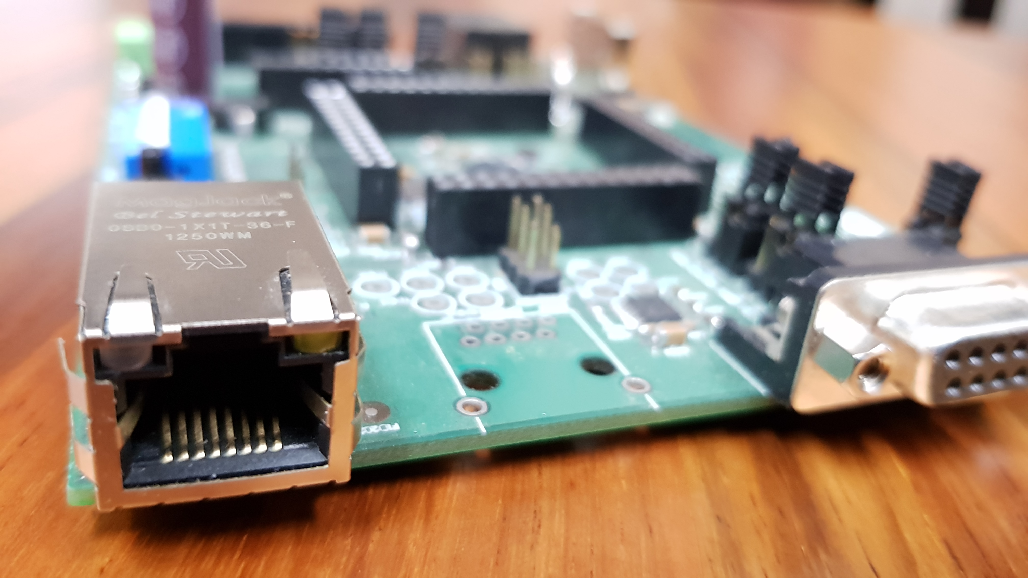



  - Mounting Brackets
Mounting Bracket Set (for Faceplate or Under-Shelf) - Powder Coated in Racking Grey supplied with Black M4 threaded mounting screws. These are dual purpose brackets for mounting the DT-5365 Operator Control Panel Box on the FP-5365 Faceplate or under a shelf / desk.

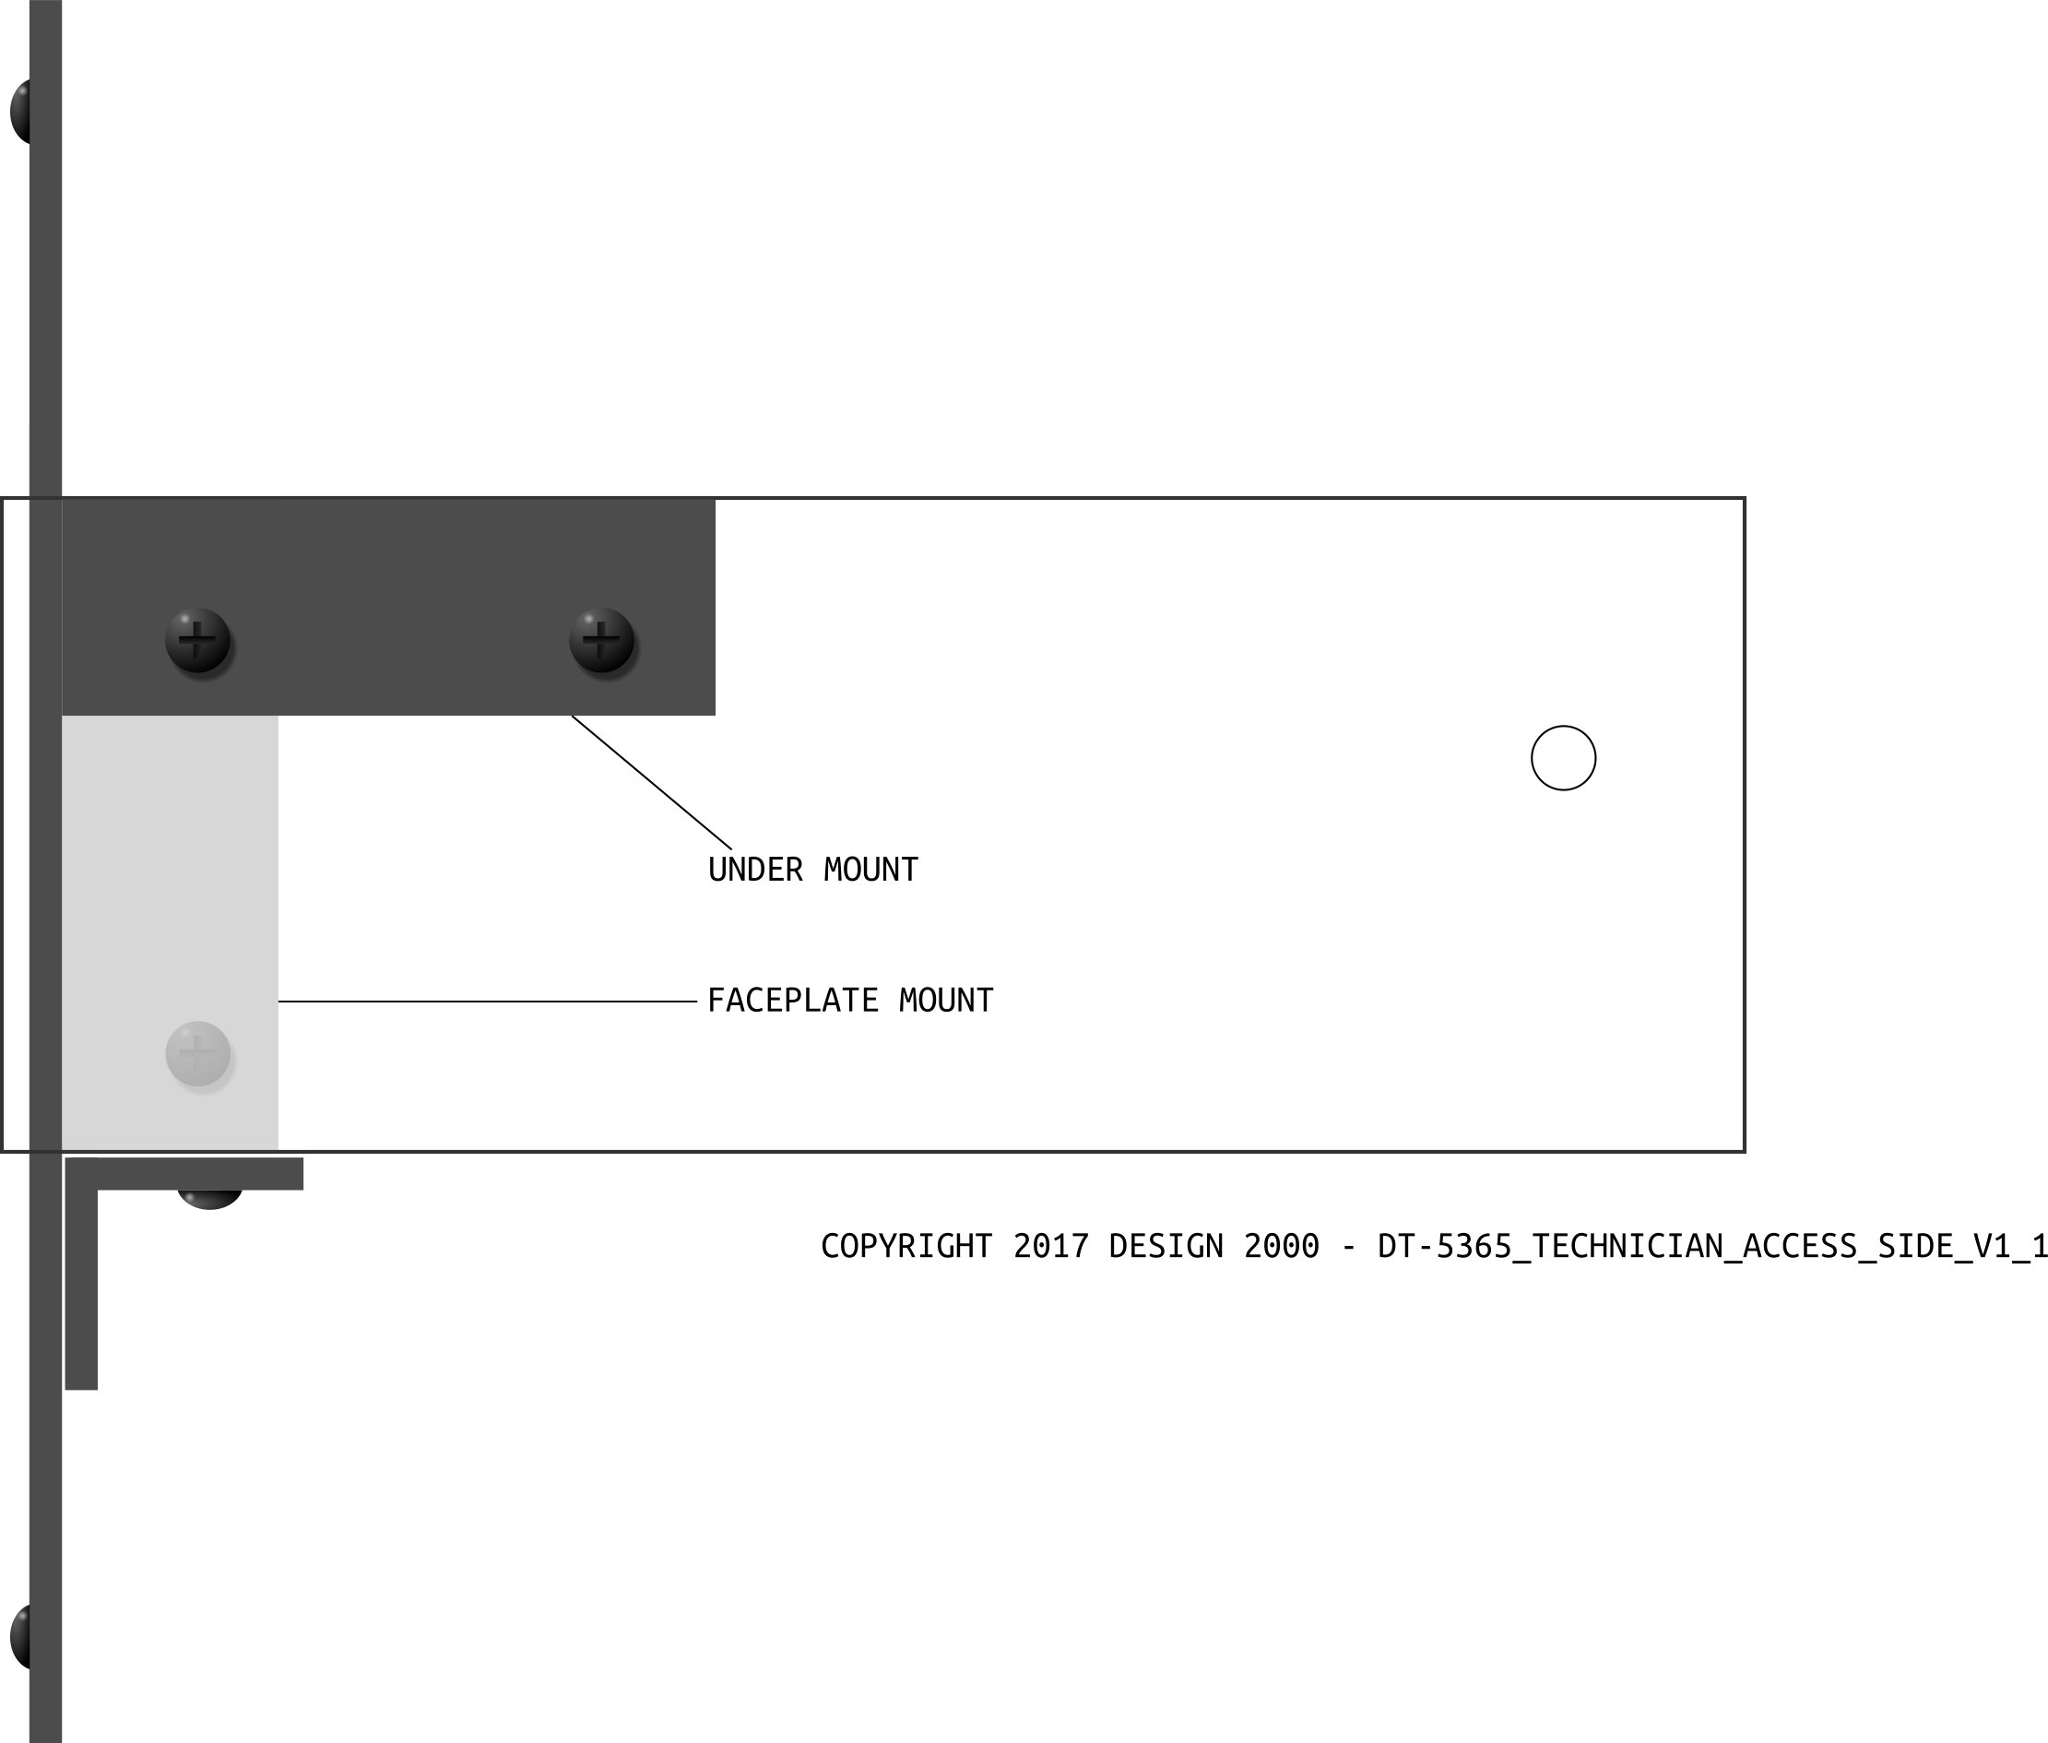

INTERFACE PIN-OUTS
FRONT PANEL

AUX MIC INPUT (RJ45)
For Motorola RMN5068A or HMN3000B-4273 Desktop Microphone, OR Pacific Wireless X10DR.

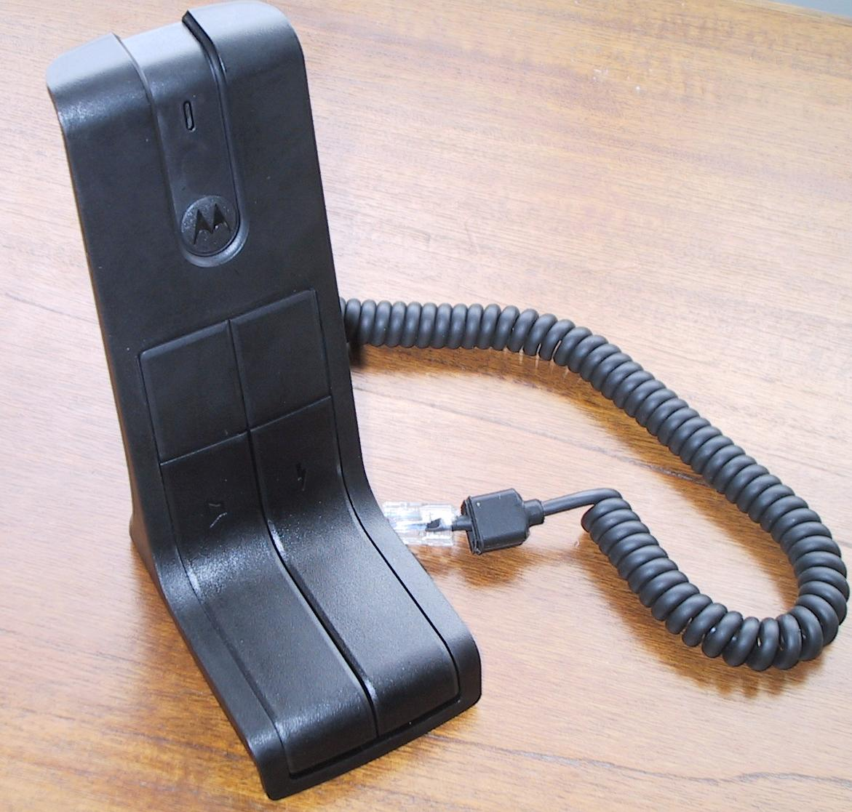

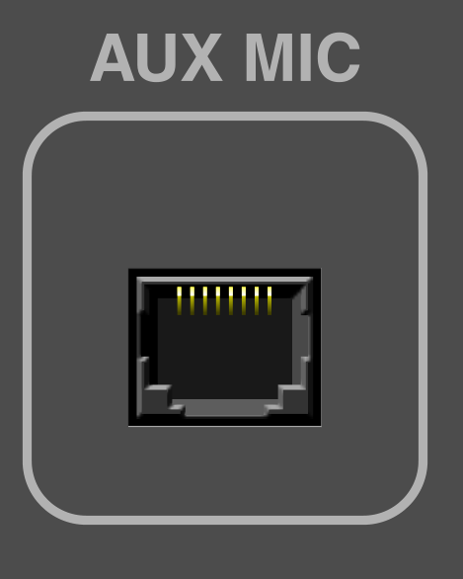

Pin Number | Description | Level / Sensitivity
1 | Power | 12V d.c. nom. 60mA
2 | Emergency output to radio | Active switched to Ground
3 | Rx audio from radio | Line level
4 | Tx audio to radio | 90mV RMS nom.
5 | Mic audio Ground | 0V
6 | Channel Activity from Radio | Unmute switched to Ground
7 | Ext PTT to radio | Switched to Ground
8 | Talkaround audio bus | Fixed line level

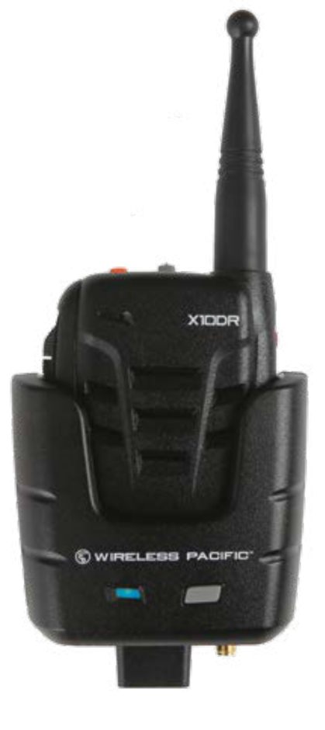

EARPHONE (3.5mm Four Pole)
For iPhone or Samsung Smartphone Earbuds with mic




Pin Number | Description | Level / Sensitivity
1 (mic) | Mic Tx audio | -34dBm nom., 5.6V bias
2 (sleeve) | Ground | 0V
3 (ring) | Right Rx audio | -10dBm nom. User adjustable Rx Level
4 (tip) | Left Rx audio | “ “ “ “

HEADSET (RJ9 also correctly called RJ22)
For Plantronics HW251N or H141N Headset


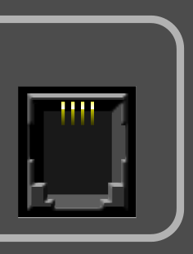

Pin Number | Description | Level / Sensitivity
1 | Speaker + | Speaker drive -10dBm nom.  (User adjustable Rx level)
2 | Microphone - | Microphone return
3 | Microphone + | -34dBm nom., 5.6V bias
4 | Speaker - | Speaker return



User adjustable earphone / headset volume control

SPEAKER VOLUME CONTROLS
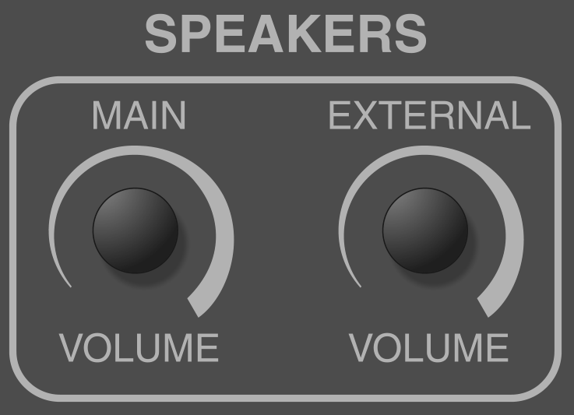

The MAIN VOLUME Control adjusts the main speaker in the FST cabinet. The EXTERNAL VOLUME Control adjusts a passive external PA speaker.

REAR PANEL

MIC CABLE HOLE
This is for the Motorola PMLN4958-03 Control Head
extension cable for the Controller Mic.

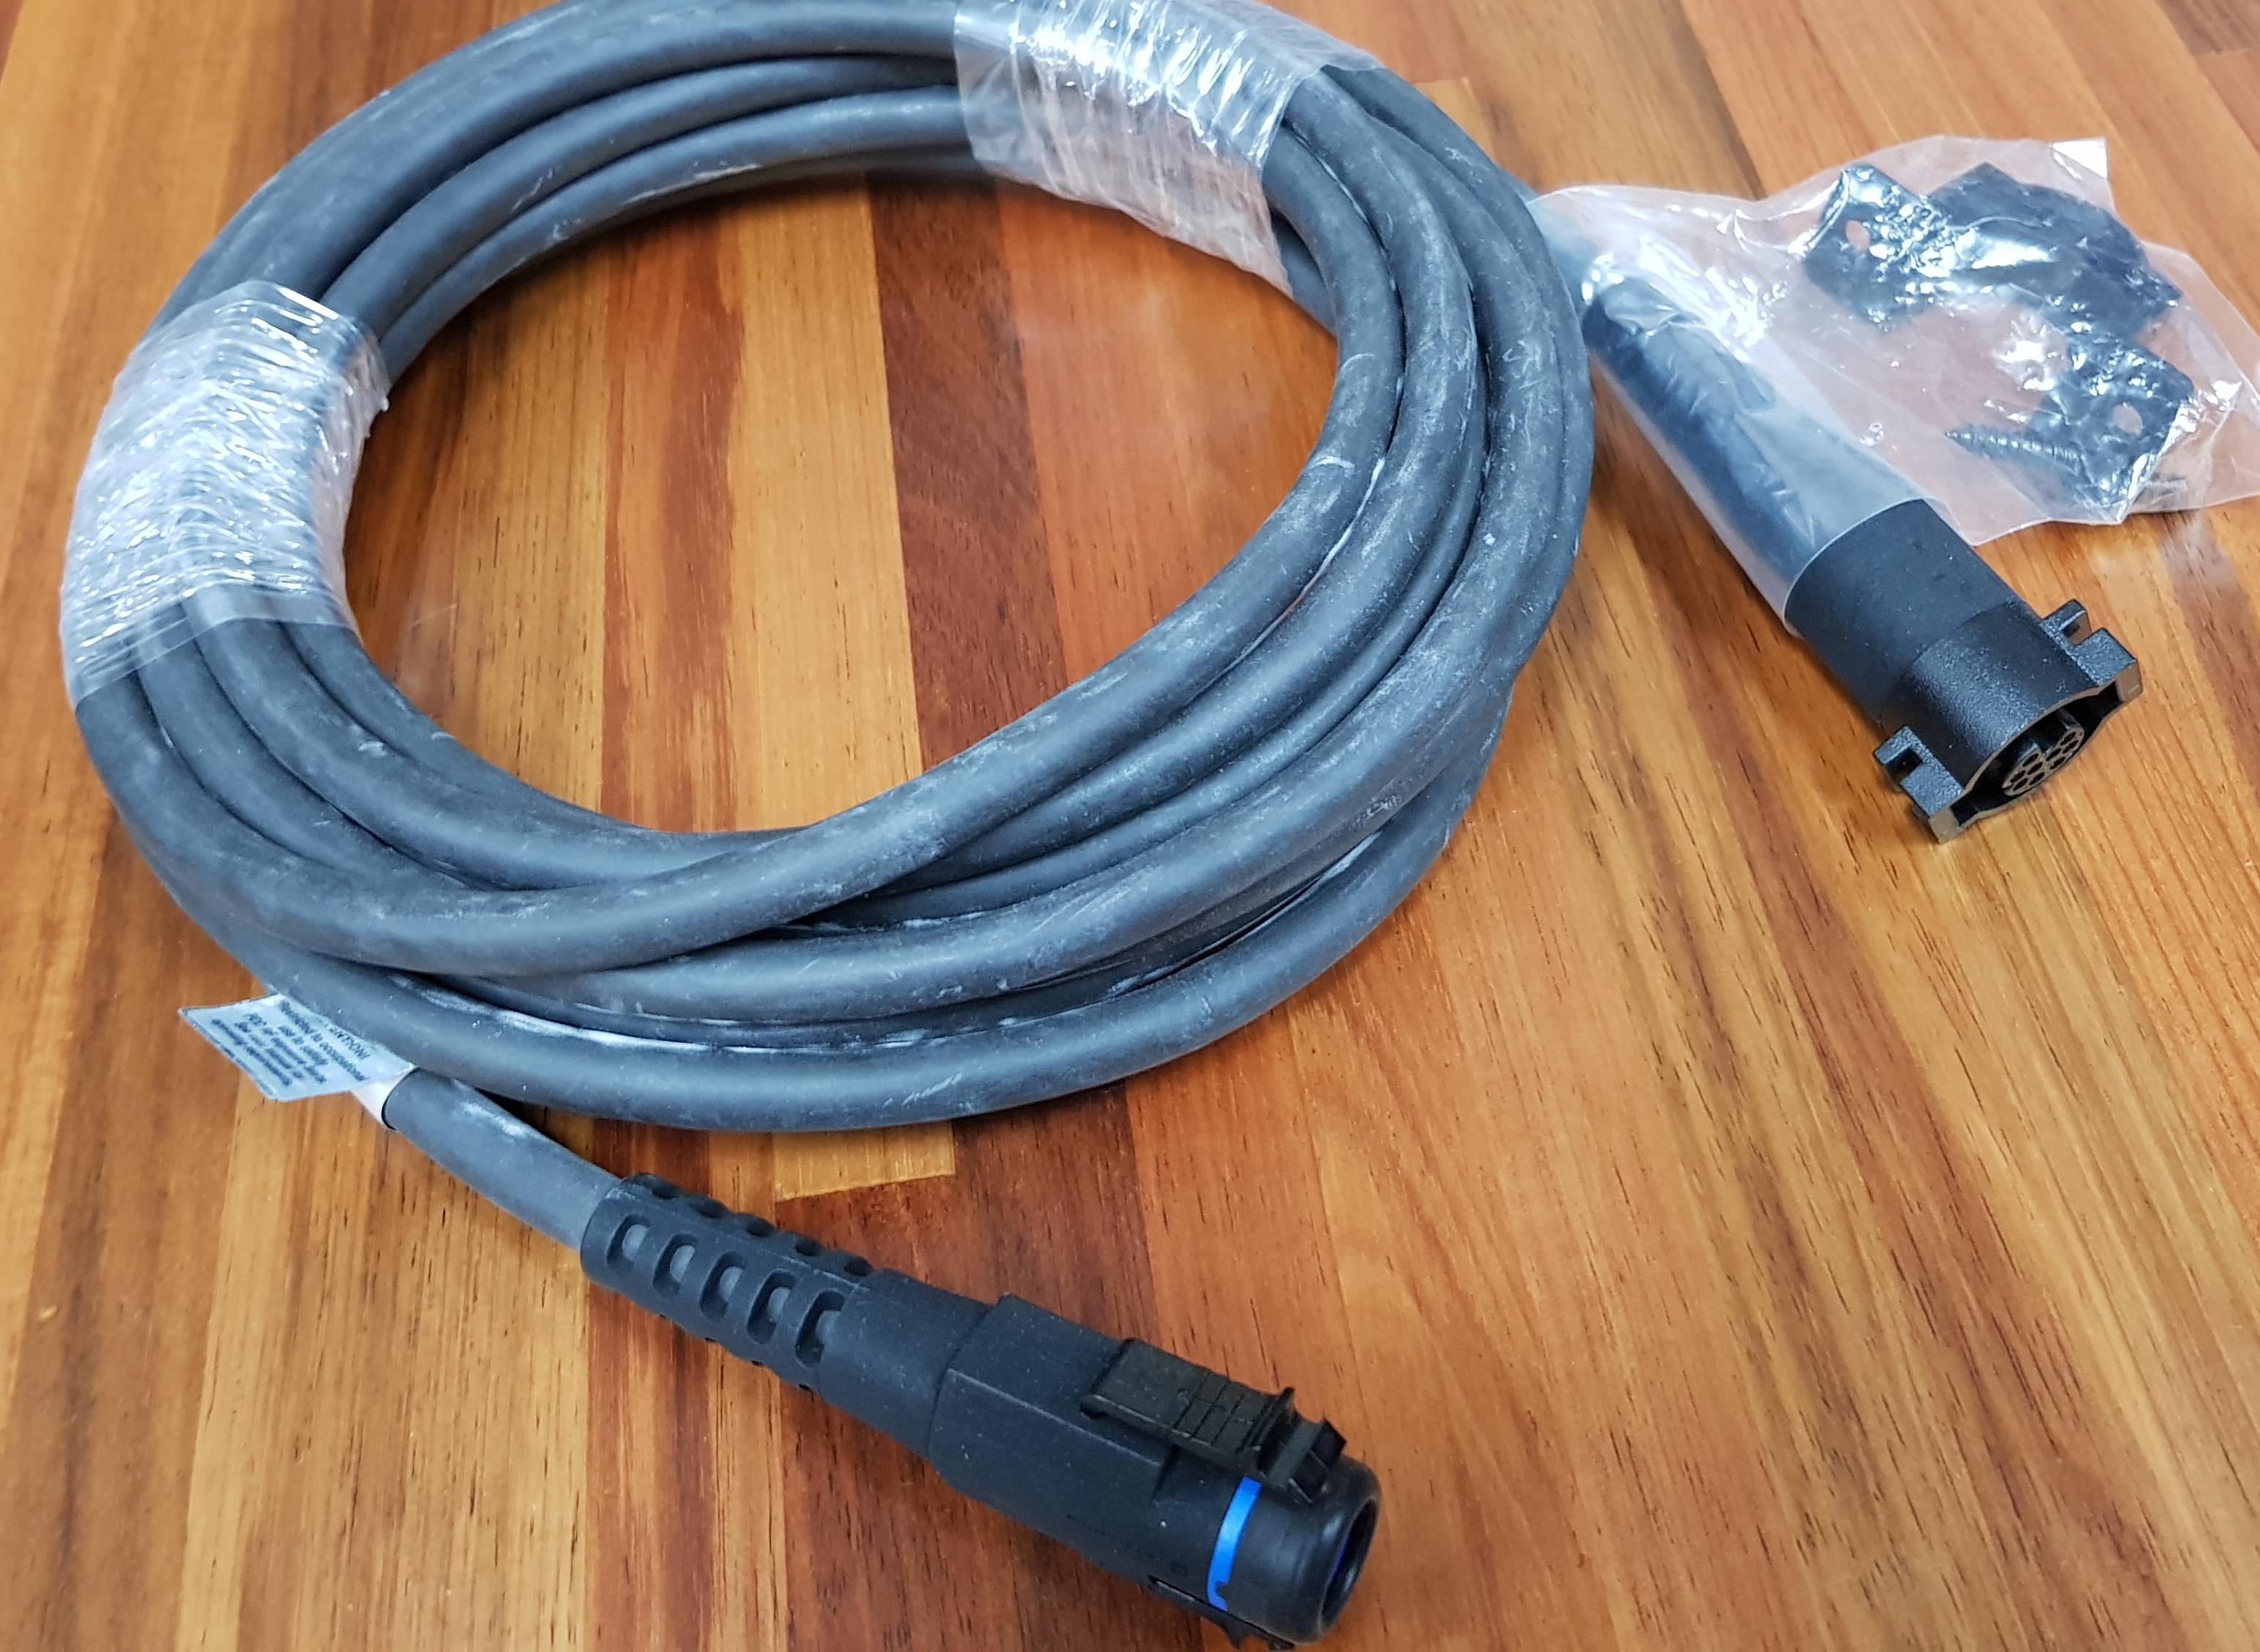

Mic extension cable pass-through hole

MAIN SPEAKER

Dinkle® Mini Pluggable Screw/Clamp Terminal

For connecting the main unpowered internal speaker (eg. 5W nom., 4 - 8 Ohm).

Pin Number | Description | Level / Sensitivity
1 | Speaker -
2 | Speaker + | 5W nom., 4-8 Ohm
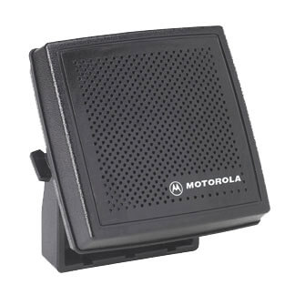

EXTENSION SPEAKER
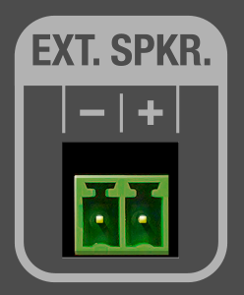
Dinkle® Mini Pluggable Screw/Clamp Terminal

For connecting an optional unpowered external speaker (eg. 5W nom., 4 - 8 Ohm).

Pin Number | Description | Level / Sensitivity
1 | Speaker -
2 | Speaker + | 5W nom., 4-8 Ohm
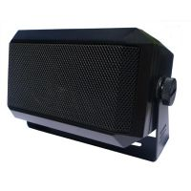

E&M INTERFACE (RJ45)
E&M (Earth & magneto, ear & mouth, or recEive and transMit) signaling provides the means to remotely signal and control the radio as well as provide external two-way audio. The E&M Interface has PTT in, Channel Activity out and 600Ω balanced Tx and Rx audio - suitable for connection to, say, a Motorola MCC7500 VPM Console, an audio bridge, a telephone interconnect unit, a Conventional Channel Gateway (CCGW) or Audio Management Unit. (AMU).


Pin-outs are shown with respect to the DT-5365.

Pin Number | Description | Level / Sensitivity
1 | PTT in | Relay normally open
2 | PTT in | Relay common
3 | Audio IN to radio J2 Accessory connector.  Audio received from the remote equipment and transmitted to operators listening to the DT-5365 | Rx audio + (-10dBm nom.)
4 | Audio OUT return | Tx Audio -
5 | Audio OUT from radio J2 Accessory connector.  Audio transmitted to the remote equipment and received by the operators listening to the remote equipment | Tx audio + (-10dBm nom.)
6 | Audio IN return | Rx audio -
7 | Chan. Activity out | Relay normally open or normally closed  (Strappable for active high or active low)
8 | Chan. Activity out | Relay common

PTT FOOTSWITCH (6.35mm Mono Jack)
For Footswitch DS2700 fitted with 2m cable and ¼” TS jack.
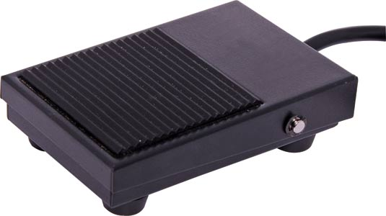

Pin Number | Description | Level / Sensitivity
Tip | Normally Open | Shorted to sleeve to activate PTT
Sleeve | Common

RADIO INTERFACE TO APX RADIO J2 CONNECTOR
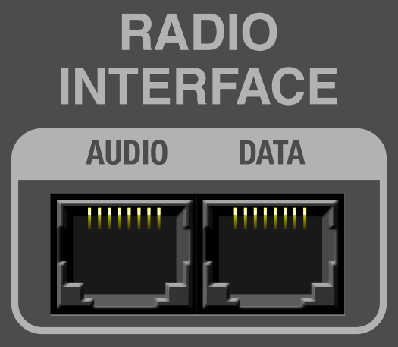

See next page for pin-out details.

AUDIO CABLE PIN-OUTS

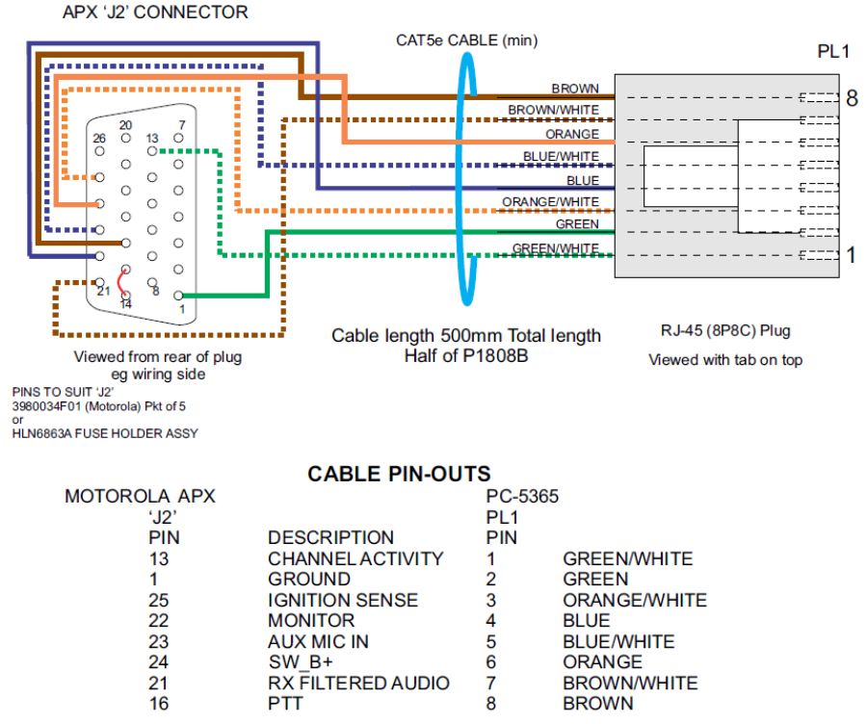

DATA CABLE PIN-OUTS

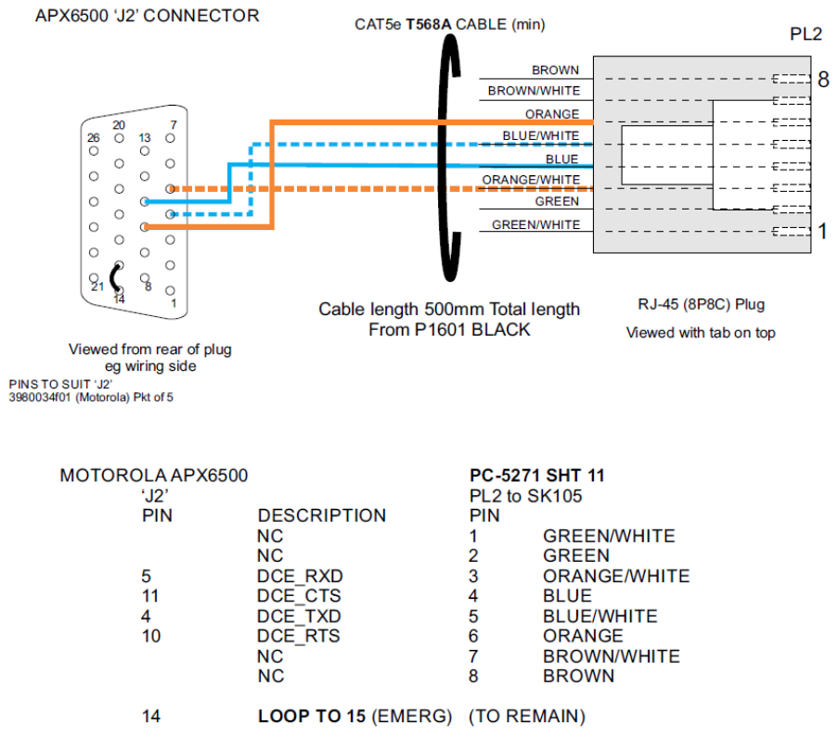

POWER INPUT

This is the power input sourced from the VIC SES standard Power Supply Arrangement.

Pin Number | Description | Level / Sensitivity
1 | -ve Return | Return
2 | +12V d.c. nom. | Power

ETHERNET CONTROLLER PORT (OPTIONAL)
RJ45 MagJack

The Ethernet jack is an IP Interface that provides an internal Web page (or Home page) for the configuration of the DT-5365.

Also on the web page, on a per application basis, custom buttons can be made available to send, say, a Status message across the P25 radio network to another radio. The construction of custom buttons is not made available to any third party and is subject to an APX ADK License Agreement on a per project basis.

As another example, the DT-5365’s IP Interface could regularly check an email account (SMTP) for mail containing a phrase or password in the title, then take action based on the body text of that email (eg. "ALERT RADIO 1234").

Pin Number | Description | Level / Sensitivity
1 | Transmit Data | TXD+
2 | Transmit Data | TXD-
3 | Receive Data | RXD+
4
5
6 | Receive Data | RXD-
7
8

Network Connection

Connect the DT-5365’s Ethernet jack to a spare LAN port on the Router or Switch using a standard CAT5, CAT5e or CAT6 network patch cable. Wait a minute or so for the Router to lease an IP address to the DT-5365 which defaults to DHCP.Open your Browser and type the DT-5365’s serial number (it’s on the back of the DT-5365) into the address bar, eg. http://RS52701337/ (include the RS and / ):

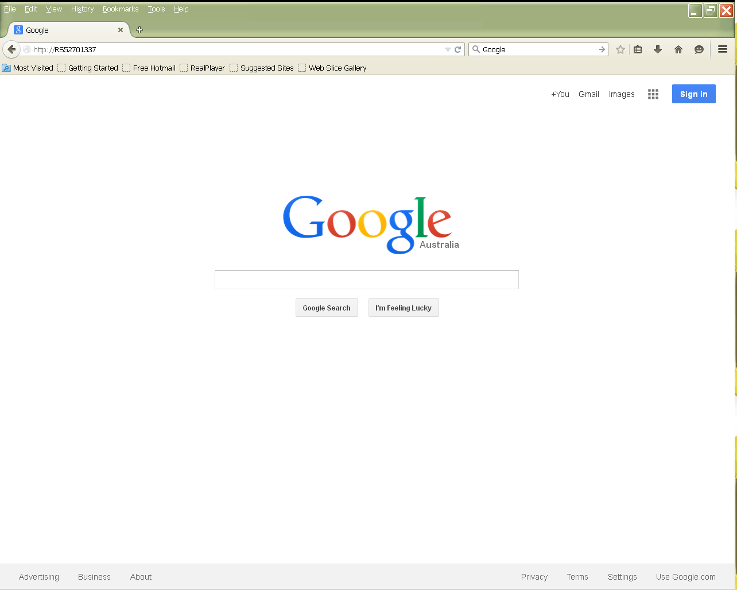
/
Press ENTER and this should bring up the Home page (example only is shown):

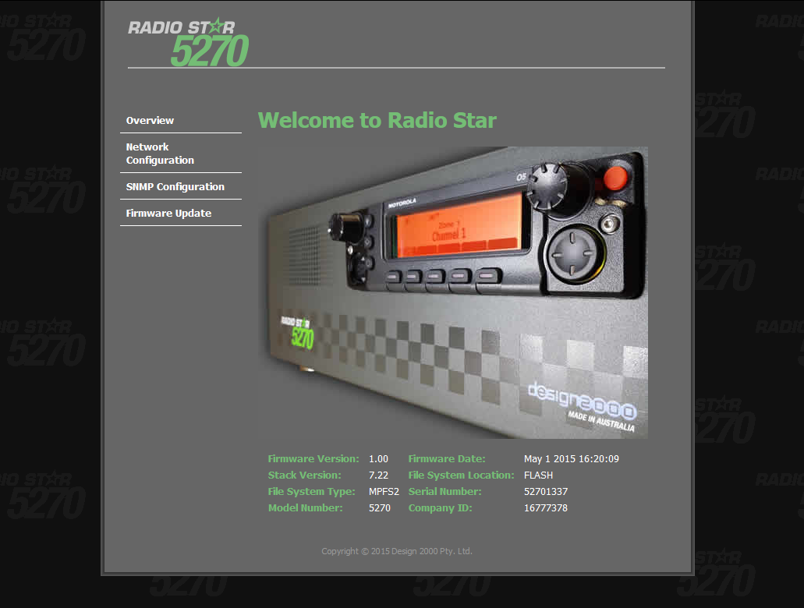

Note that your Browser may do a Google search and not find the DT-5365. Contact your Network administrator for instructions on how to do a local search.

4 EMC COMPATIBILITY
The Motorola APX Mobile Terminal and DT-5365 Control Box meets the requirements of AS/ANZ 3548-1995, EN55022 (CISPR22), GB9254 Class B, EN55014, EN61000-3-2,-3 and for immunity EN61000-4-2,3,4,5,6,8,11, EN61000-6-2 (EN50082-2), heavy industry level, criteria A.

INSTALLATION: GENERAL
The relevant subsections & Installation check sheet for FST installation are covered in other Motorola documentation. Please consult your Fixed Station Terminal Manager as required.

Aesthetics
Check that the equipment has no marks or damage that detracts from the equipment and appearance of the installation. More substantial marks and damage may affect equipment performance. An example of which may be a cracked case or damaged controller microphone inhibiting the function of the push buttons.

Appendix A - Feature Sets

FEATURE | DT-5365 | DT-5365P

Appendix B - Circuit Diagram - Hierarchy Schematic

Appendix C - Circuit Diagram - Audio, E&M Schematic

Appendix D - Circuit Diagram – Amplifiers Schematic

Appendix E - Circuit Diagram – Sub-board Schematic

Appendix F - Circuit Diagram – Power Supply Schematic

